Article ID: 1075
Article Name: The rubber door seal of my washing machine has come loose.
Topic Location: Laundry, Washing Machine, Door
Meta-data: Gasket, seal, rubber, door
Related Articles:
Related Questions:
PNC
DIY
Safety
Link
Email
Book Engineer
Multimedia
Brand
Article Content:

A loose, damaged or deformed seal has to be fixed or replaced by an authorized technician/engineer, otherwise this can result in leaks.
Please don’t use the appliance until the problem is fixed.
We recommend that one of our Authorised Service Engineers should visit you, at a date to be agreed, in order to resolve the problem.
Please book an engineer by pressing the button below.
[book_engineer_link]
When you contact us to make your appointment, please ensure that you have the product number (PNC) and serial number of your appliance ready, as this is important information that will assist our engineer when they visit.
Rating plate with model number, product number/PNC, ELC number and serial number:
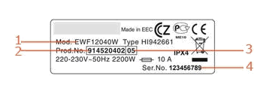 | 1. Model number  2. Product Number  3. ELC number  4. Serial Number
Where to find the rating plate at your appliance: [3-9999]Where to find the rating plate?
Please be aware that depending on your warranty conditions, you may be charged for the visit.
ATTENTION: Do not use the appliance untill the problem is determined. Unplug the appliance from the power supply, close the water supply and make sure, that nobody in your household re-plug / re-open it or tries to use the appliance until it is repaired.

